Our goal for today is to discuss dual abelian schemes, isogeny, and polarization. We begin by recalling the Theorem of the Cube (or Cubical Structure Theorem).

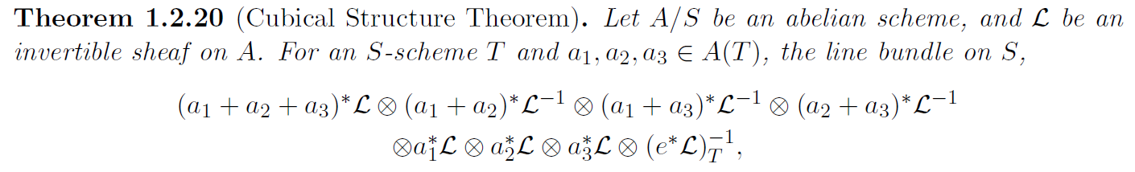

In the above, e denotes the identity section in A(S). We will mine this result for useful consequences. First, though, we have the following useful construction.

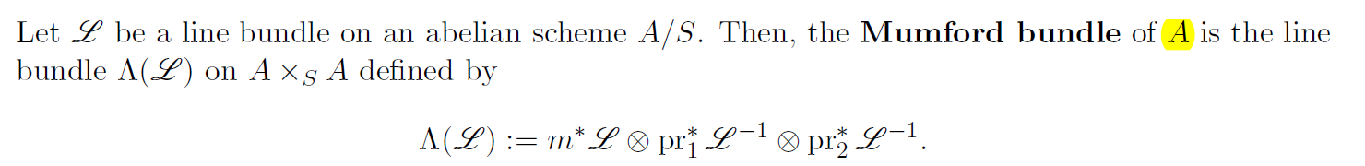

We have the following.

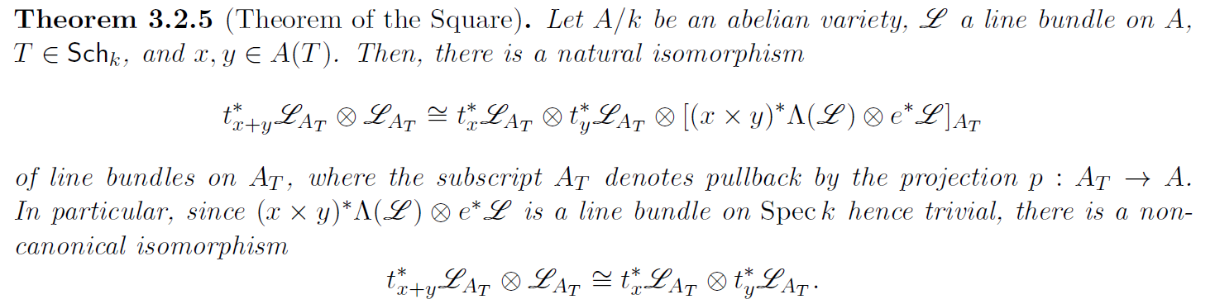

The first part of this holds for a general abelian scheme A/S. Here’s the proof (Corollary 3.2.3 refers to the Theorem of the Cube).

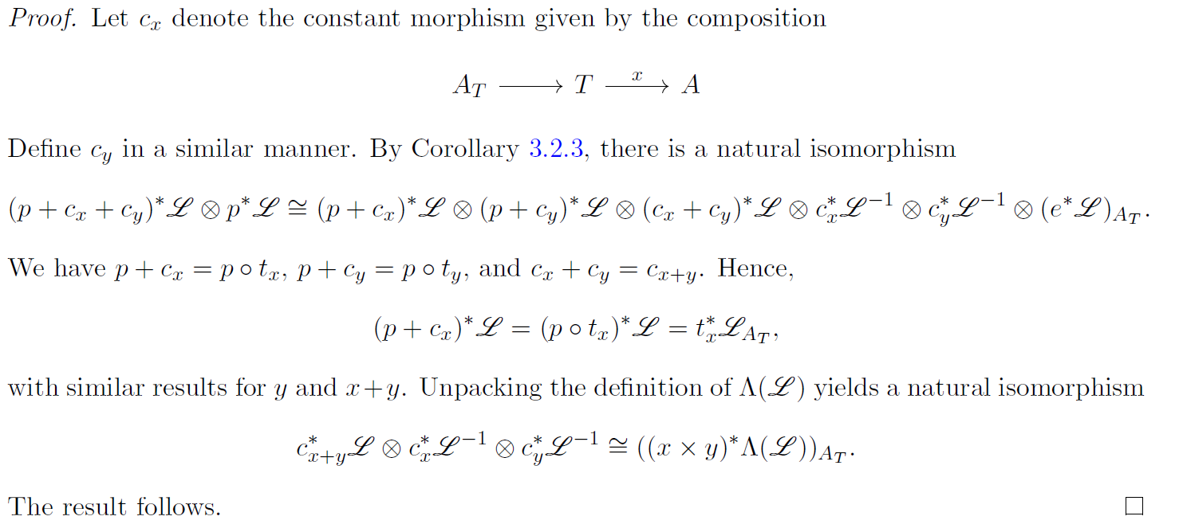

This is in turn gives us the following result.

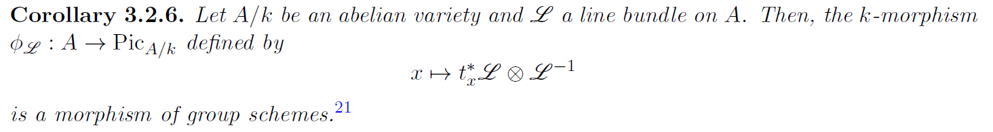



Morphisms of this sort are important for their relationship to dual abelian schemes, as we will soon see.

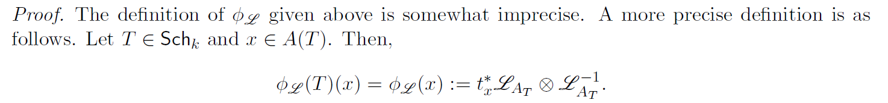

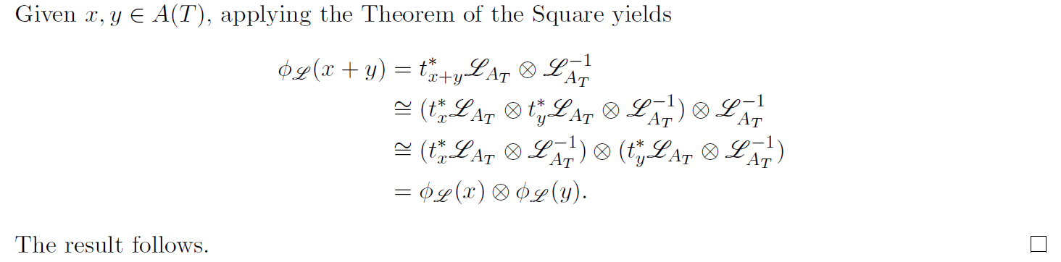

Borrowing Oh’s notation, let Pic_{A/k}^{0c} denote the connected component subgroup scheme of Pic_{A/k} for A/k an abelian variety. In this case, we claim that Pic_{A/k}^{0c} represents the functor Pic_{A/k}^0 as defined by Oh. But before we do that, here’s a quick interlude on Poincare bundles.

X below is a suitable k-scheme for which Pic_{X/k} is representable (specifically, X is proper, geometrically reduced, and geometrically connected equipped with a k-point e). A^{\vee} here is the same as Pic_{A/k}^{0c}.

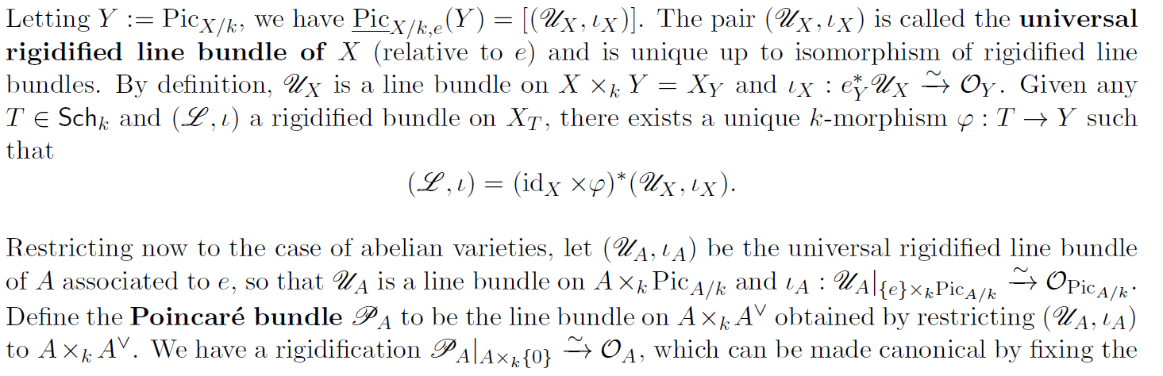

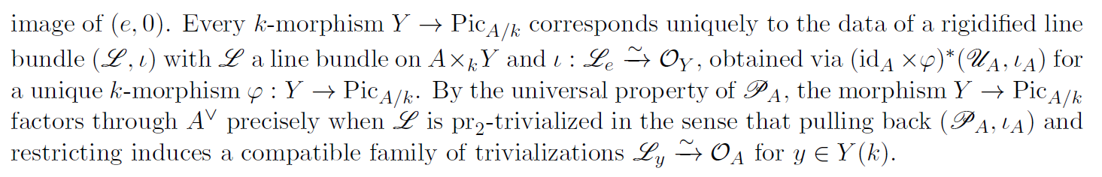

This last bit is a restatement of the claim we want to show.

Elaborating, for one direction we have:

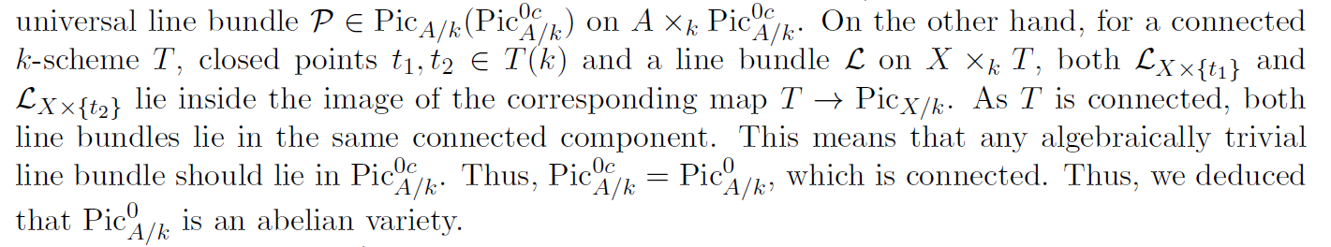

What about the other direction? Given L a line bundle on A, we claim that:

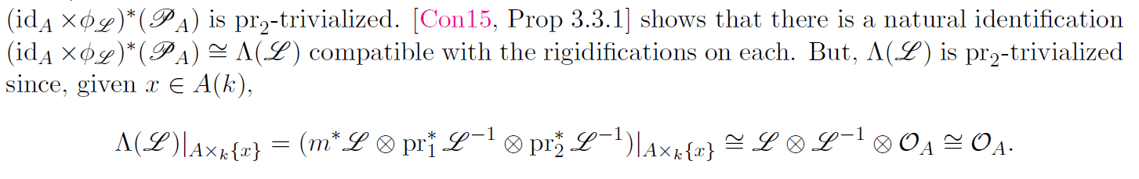

We conclude from this that Pic_{A/k}^{0c} represents Pic_{A/k}^0 (and we call both A^{\vee}). In fact, we can say more. The above shows that \phi_L factors through A^{\vee} and that \phi_L=0 if L is a k-point of A^{\vee}. We can approach all of this from a slightly different perspective.

Bhatt uses a result called the Seesaw Theorem to construct K(L) a maximal closed subscheme K(L) in A such that the restriction of the Mumford bundle \Lambda(L) to K(L)\times_SA (this works for any abelian scheme A/S, not just when S=Spec k) is pulled back from K(L). Bhatt then deduces the following result.



We conclude that K(L) is a subgroup scheme of A, given by ker(\phi_L), and that |K(L)| is given by x\in A such that t_x^*L \iso L (i.e., the translation-invariant locus of L).

Theorem: Pic_{A/S}^0 is representable for A/S an abelian scheme. Moreover, the representing S-scheme is abelian (which we denote A^{\vee} as above).

Proof: Oh deduces the result for general S by combining the fiberwise result with global considerations. For S=Spec k, we already know that Pic_{A/k}^0 is represented by Pic_{A/k}^{0c}=A^{\vee}. Such a scheme is geometrically connected by construction. Sidd proved that this is formally smooth, so showing properness is all that remains. But we already know the sufficient result that Pic_{A/k} itself is proper (which can be deduced explicitly using the valuative criterion of properness).

Switching gears a bit, we have the somewhat amazing result that abelian varieties are always projective.

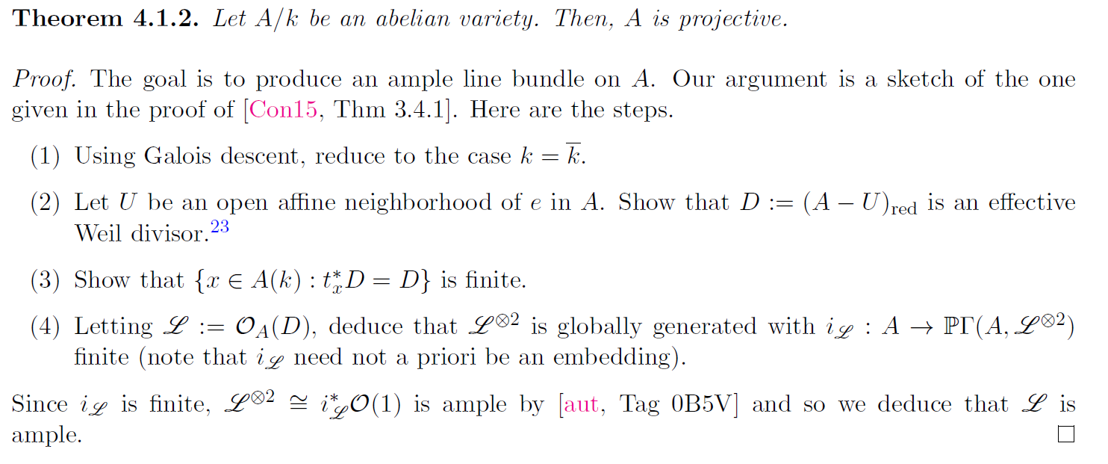

The divisor result is included here, for completeness.

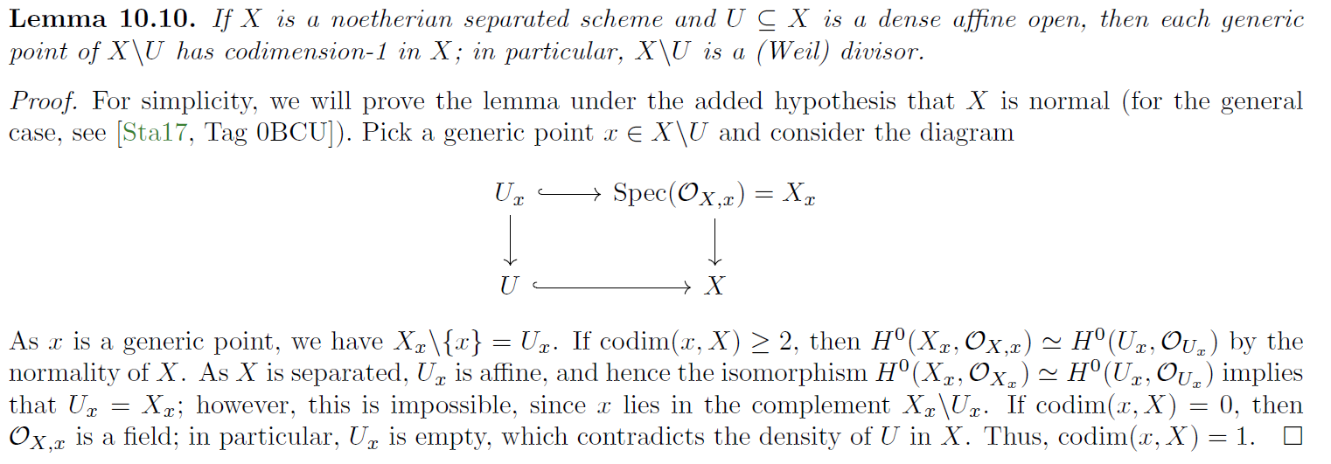

Oh takes a different approach to showing projectivity.

1. Same as before.
2. Find finite set {Z_1,…,Z_n} of codim 1 integral subschemes of A whose intersection is {e} and such that every nonzero tangent vector in T_eA is not contained in at least one T_eZ_i.
3. Define D to be the divisor that is the sum of the Z_i. Oh shows that |3D| separates points and tangent vectors and so 3D is ample.

Definition: A morphism f: X\to Y of S-schemes is an **isogeny** if it is surjective and ker(f) is a finite flat S-group scheme. If such an isogeny exists then we say that X and Y are **isogenous** (we will see soon that this is a symmetric hence equivalence relation). Degree makes sense as a fiberwise notion: if S=Spec k then we define deg(f) to be [k(X):k(Y)] (which is necessarily finite). The following result concerns what is perhaps the most important example of an isogeny.



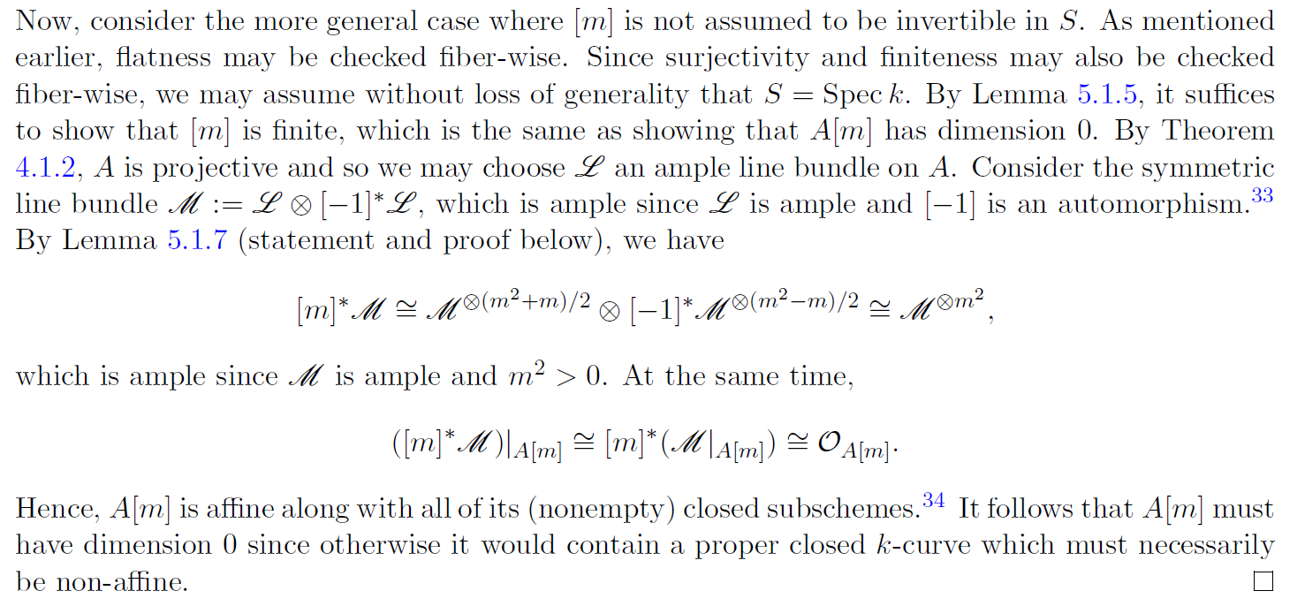



Of course, in the case that m is invertible in S we already know the stronger result that [m] is etale.

The following works for a general abelian scheme A/S, since Corollary 3.2.3 is none other than the Theorem of the Cube.

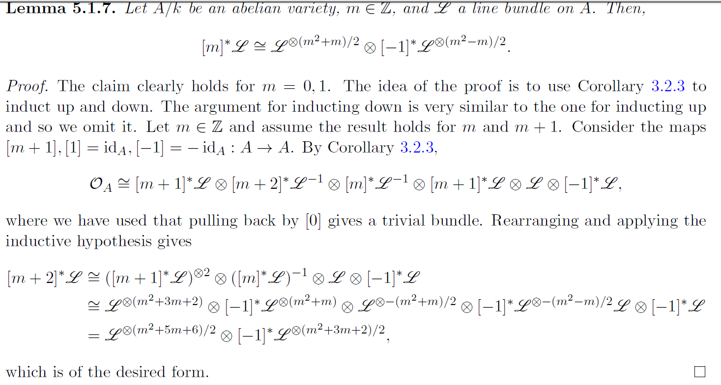

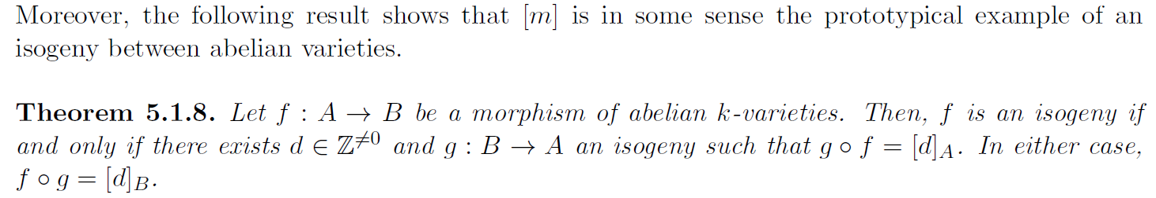

For the forward direction, we can choose d to be deg(f). For the backward direction, the degree of f as an isogeny will be d. This shows that isogeny defines a symmetric hence equivalence relation. We can then pass to the isogeny category, as we have done in the past.

Definition: A **polarization** is as an isogeny from A to A^{\vee}. A polarization is **principal** if it is an isomorphism – i.e., it has degree 1.

Remark: There are many alternative characterizations of what it means for a polarization to be principal, each capturing important information. Principal polarizations are also useful for studying abelian schemes and varieties in families – i.e., for the purposes of moduli problems.



